**Middle School Summer Reading Challenge**

* Log into Clever and select the Middle School Summer Reading Challenge tab.
* Click on the link for the grade level you will be entering for the 2025-26 school year.
* Complete the Escape Room activities for your assigned book:
  + 7th grade ***Futureland*** *(Current students will receive their book prior to start of summer. If you have not received the book, you may stop by the school office to pick up a copy.)*

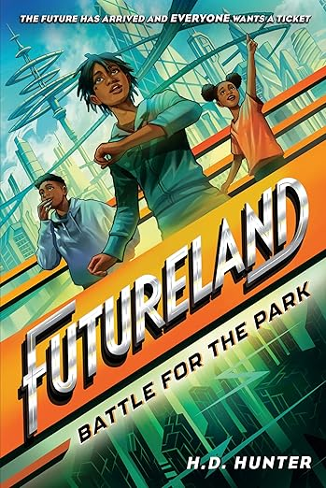

* + 8th grade ***Mission Multiverse*** *(Parents/students will be able to stop by the school office starting on June 16th-June 26th from 8 am to Noon to pick up a copy of the text.)*

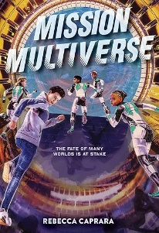

* After finishing the Escape Room, you will be prompted to complete a **Form**. This will let us know who earned the prize, so that we may give it to you as the 2025-26 school year begins.

**Additional Summer Challenges**

**Reading BINGO**

Visit the PCS Middle School page and click on the ELA BINGO Card for either Informational or Literary text. Complete the activities, then submit the Form Linked on the card to finish your BINGO challenge.